SQL for Software Testers – Homework 1

# Write a *query* to select all the customers that have contact title Sales Agent.

* **Query Answer Below:**

# Write a *query* to select all the customers that have region different than NULL.

* 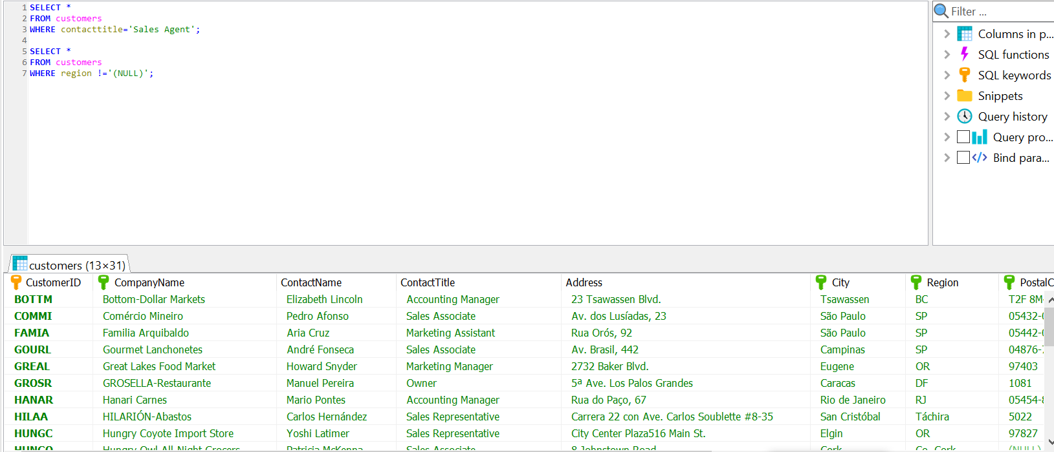**Query Answer Below:**

1. Write a *query* to list Name and Surname for every employee that is from London.

* **Query Answer Below:**

# Write a *query* to get list of all Order ID’s which are more than 20 in quantity.

* **Query Answer Below:**

# Write a *query* to select the unit price and quantity of the products that have discount.

* **Query Answer Below:**

# Write a *query* to list only the product name (in products table) for all the items that are not in stock.

* **Query Answer Below:**

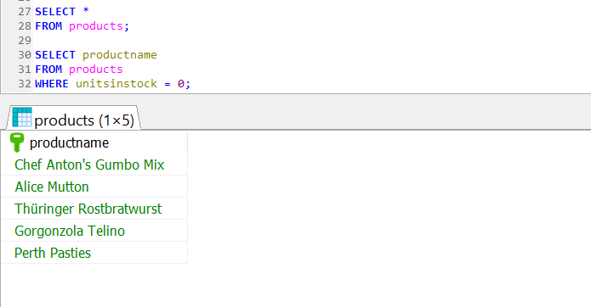

# Write *query* to list all orders which have value of Shipped Via 2 or less.

* **Query Answer Below:**

